**Noreastcon 52 Model Show**

**Freeport Recreation Center**

**130**

**E. Merrick Road**

**Freeport, NY 11520**

Need Info? Internet site: WWW.LISMS-IPMS.ORG

**..**

ORGO

or mail Jim at:[**jnboul19@yahoo.com**](mailto:jnboul19@yahoo.com)

Special Theme Award is the 80th Anniversary of the D-day Invasion.

**21Club Anniversary**

**Visit our website for updates fort for with**

**contest rules, categories, registration/entry forms, vendor, and sponsor info.**

**registration**

**Event Activities**

⇒

**Hundreds of Aircraft, Armor,**

**Ships, Autos, Sci-Fi**

**-**

**, Figures,**

**and Diorama Displays**

⇒

**50**

**+ Contest Categories**

⇒

**1**

**st, 2nd, 3rd Place Awards**

⇒

**Gundam Categories**

⇒

**Lots of Vendors**

⇒

**Raffle**

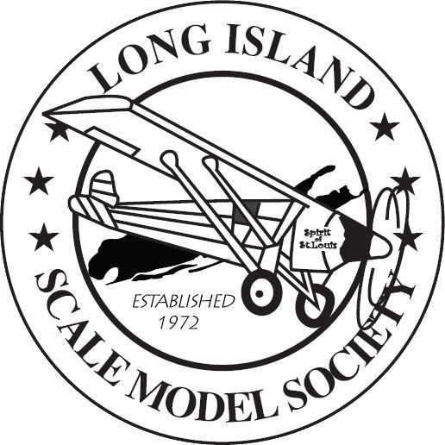

**ADMISSIONS:**

Contest Entrants

Adults --- $15.00 – limited to 15 model entries ($1.00 extra per model over 15)

Junior --- $7.00 (Under 17 years of age)

Visitors

Adult ---$10.00

7 to 17 years of age --- $5.00

Seniors 65+ & Vets --- $5.00

Current Military --- Free

Junior --- $7:00 Under 17 years of age)

Visitors:

Adult ---$10:00

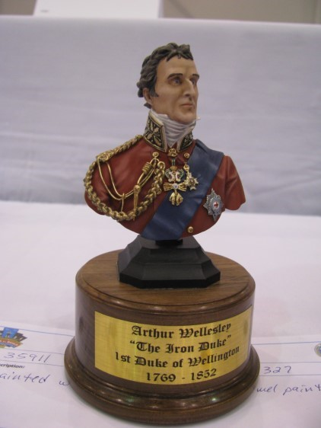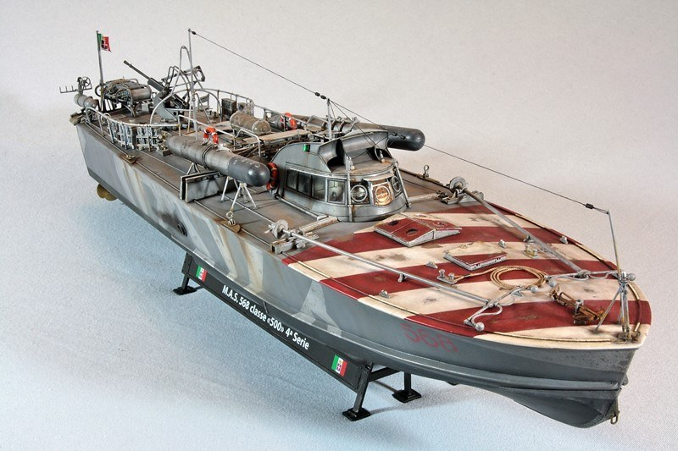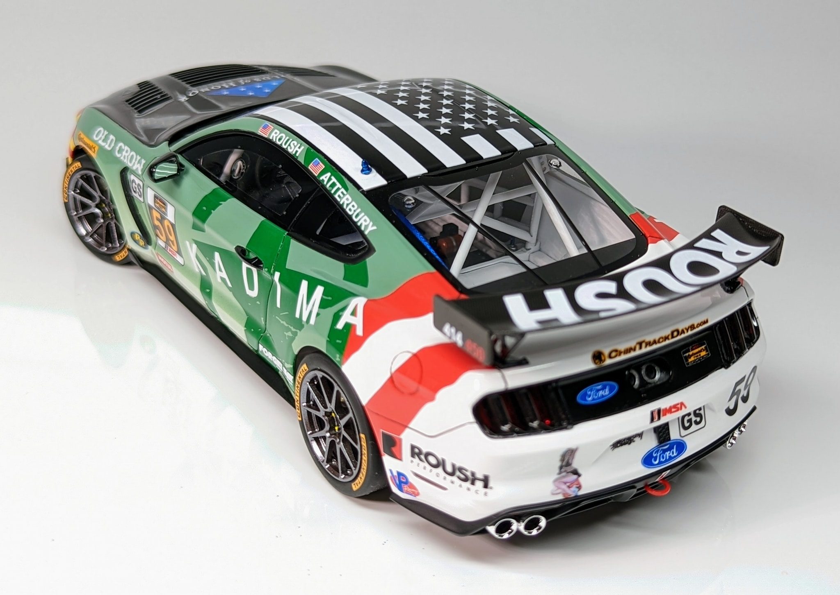

**Be part of the longest running IPMS Regional in the country hosted by the Long Island Scale Modeler Society**

**Saturday, March 23, 2024**

**9**

**am to 4 pm**

